Updated 1/7/24

Green - MS/HS Snow & Emergency Route

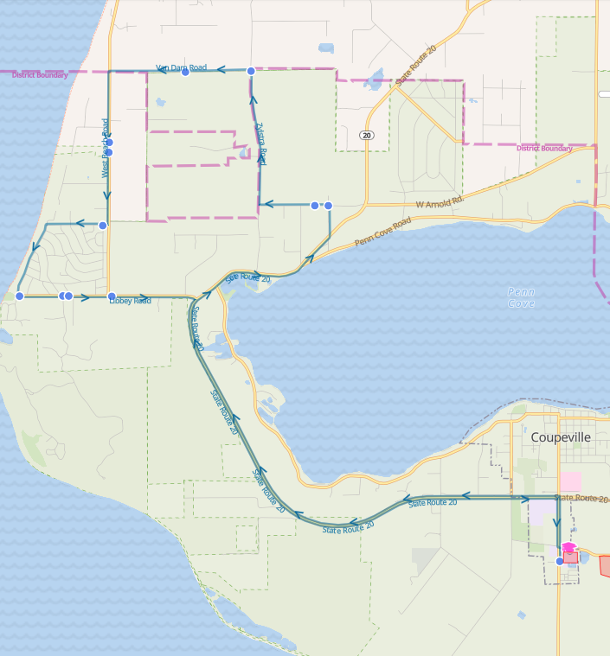

Green - MS/HS Snow & Emergency Route

Reg Start 2- Hr. Delay
7:01 AM | 9:01 AM | Arnold Rd & Holbrook Rd
7:02 AM | 9:02 AM | 1948 Arnold Rd
7:06 AM | 9:06 AM | Zylstra Rd & Van Dam Rd
7:09 AM | 9:09 AM | 2290 Van Dam Rd
7:12 AM | 9:12 AM | 1004 West Beach Rd
7:13 AM | 9:13 AM | 981 West Beach Rd
7:15 AM | 9:15 AM | La Mesa Dr & El Pozo St
7:19 AM | 9:19 AM | Fort Ebey Rd & Libbey Rd
7:20 AM | 9:20 AM | Libbey Rd & Hill Valley Dr
7:21 AM | 9:21 AM | Coronado Ave & Libbey Rd
7:22 AM | 9:22 AM | 2494 Libbey Rd

Green - Elementary Snow & Emergency Route

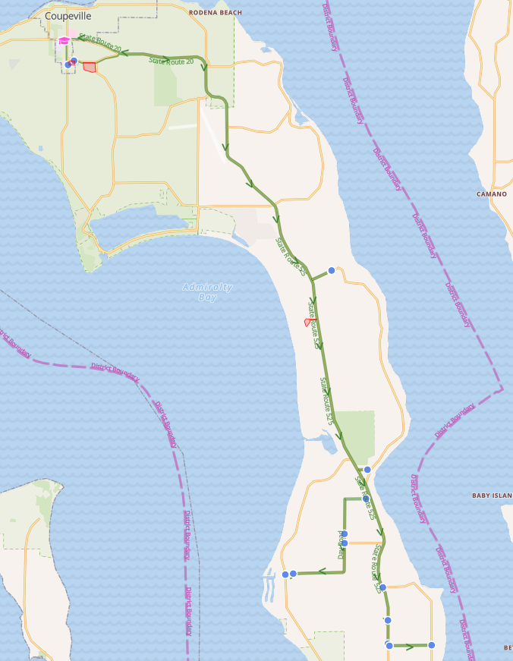

Green - Elementary Snow & Emergency Route

Reg Start 2- Hr. Delay
7:52 AM | 9:52 AM | Bakken Rd & Firehouse Rd
7:59 AM | 9:59 AM | Lagoon Point Rd & Gylany Way
8:00 AM | 10:00 AM | Lagoon Point Rd & Smugglers Cove Rd (Fire House)
8:04 AM | 10:04 AM | Day Rd & Christenson Rd
8:04 AM | 10:04 AM | 3339 Day Rd
8:11 AM | 10:11 AM | 22899 SR 525
8:11 AM | 10:11 AM | SR 525 & Classic Rd
8:12 AM | 10:12 AM | 908 Classic Rd
8:14 AM | 10:14 AM | Classic Rd & Honeymoon Bay Rd
8:19 AM | 10:19 AM | SR 525 & Resort Rd
8:23 AM | 10:23 AM | Wonn Rd (Greenbank Farm Drive)
8:33 AM | 10:33 AM | Houston Rd & Grateful Acre Pl

